SRM Institute of Science and Technology, Kattankulathur
Department of Mathematics
Assignment-II
18MAB201T-Transforms and Boundary Value Problems
Academic Year: 2021-2022
Answer All the Questions (5 * 12=60 Marks)
- Find the Fourier series to represent the function f(x) given by 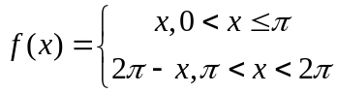. Hence deduce that 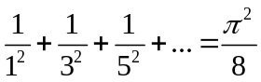
- Find the Fourier series for the function 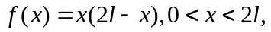 hence deduce that 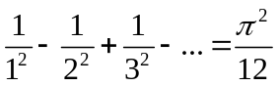
- Find the Fourier series as far as the second harmonic to represent the function given by the following data:
X | 0 | 1 | 2 | 3 | 4 | 5
f(x) | 9 | 18 | 24 | 28 | 26 | 20

- A tightly stretched string of length l has its end fastened at x=0, x=l. At t=0 the string is in the form f(x)=kx(l-x) and released. Find the displacement at any point on the string at a distance x from one end and at any time t>0.
- A rod 30cm long has its ends A and B kept at 20C and 80C respectively, until steady state conditions prevail. The temperature at each end is then suddenly reduced to 0C and kept so. Find the resulting temperature u(x,t) taking x=0 at A.

